Professional Reflection

Coding offers a lot of different contributing factors to what makes the program sufficient and acceptable for a professional level of coding. Understanding the syntax of a language is just one factor; other important factors that help to produce some of the most user-friendly, easy to maintain and overall, well-developed software are things such as code readability and its ethical structure (in areas such as bias, privacy and computer misuse) and how these coding choices have effects on real-world products. This reflection will help depict each of these and display why they are each an important factor in production standard professional code, and examples of how this is done.
Readable code is particularly important when developing code, as majority of software development roles incorporate working collaboratively as a team. Whilst working as a team, it is common for multiple members to be working on the same piece of code, which is where readability can help the collaboration and allow easier input from each member. For example, well-defined variables in code or descriptive names can help members understand what these variables or pieces of code represent. If code is not named correctly, then it could be misunderstood as to what that code is doing, and misinterpretation of the code could be taken the wrong way and be misconfigured.
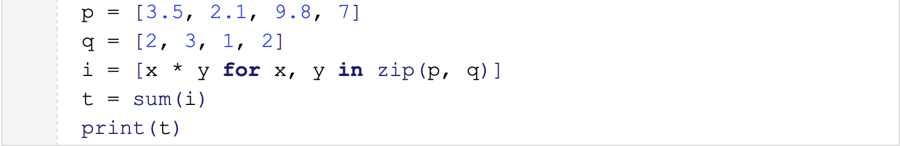
Figure 1: An example of a bad naming convention for variables in Python (Gruppetta, 2021).
As seen in the figure above, these variables are not defined very well, leaving a colleague who attempts to collaborate having to make assumptions about what they are doing, which could lead to misinterpretation and faulty code down the line.
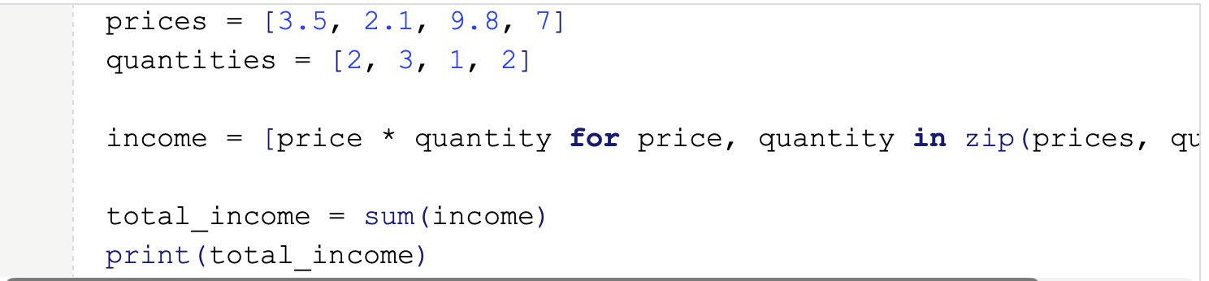
Figure 2: Clean and readable defined variables in Python (Gruppetta, 2021).
In Figure 2, there is a clear and descriptive name for each of the list names and the list comprehension function, allowing for a clear understanding of what each of these sets of values represents and what the list comprehension is trying to calculate. This is significantly important as it allows a clear understanding of what the code is trying to produce and can help equally in troubleshooting if it is not working as intended. Standards such as PEP 8 for Python have been created to help programmers develop readable code and follow logical flows, enabling greater collaboration around the world, which also displays the importance of comments for readability (Van Rossum, 2001). Comments can be used to describe or label in plain text without affecting the code written. This gives a precise, clear text explanation to help further describe what is going on in the code.
With software and programming becoming global with advancements in technology and deployment, using services such as AWS, it is ever more important to incorporate ethical considerations when writing code. With so many different cultures and backgrounds interacting with each other, especially for large companies, it is necessary to accommodate and be aware of different cultural beliefs and avoid stereotypical references. Names of variables or descriptive areas have been introduced with their importance again in this area, while also trying to stay away from discriminatory names such as ‘blacklist’ or ‘whitelist’ (Walton, 2024). Gender-fluid naming conventions are also a good approach allowing for the accidental assumptions and going for a more neutral base, such as ‘they/them’. Another key ethical consideration is date and time, allowing for different time zones from around the world, not just the current local zone. Different date formats can be a key consideration in things such as the American date ‘month/day/year’ versus the English in ‘day/month/year’. A more common misinterpretation that can show up in ethical consideration would be the ability to accommodate different cultural currencies and measurement units (Walton, 2024). A simple solution for this would be to incorporate a simple conversion function depending on the software user’s preference to convert into their chosen metric unit or currency. Amongst all this consideration of ethical reasoning, there is undoubtedly more to be considered, and with a strong software development cycle such as Agile to help perform feedback and routine testing iteration cycles and updates, these can be implemented to provide a comfortable user experience for all backgrounds.
With the rise of Artificial Intelligence, particularly machine learning algorithms, a key processing that is implemented in the development would bias detection. Machine learning makes use of the large datasets that are collected from any sort of digital appliance, and companies use these datasets to help personalise and gain insights into their data to help produce more efficient and direct user experience or company output. Some of these datasets can hold societal or cultural biases and have imbalances in the data, therefore producing unfair or discriminatory outputs, which could cause companies or enterprises to lose trust and ruin their reputation as well as face unlawful consequences. Creating biases for these is crucial for diversity and inclusivity (Walton, 2024). Mitigations can be done in AI models’ preprocessing steps by inspecting the data and checking that each ethical background or cultural difference is equally represented in the dataset so that the model is trained and has the same amount of training on the data to accurately predict future predictions. This could also be done by resampling the test data to provide unbiased data to the training model.
Relating to the previous topic of using large datasets that are collected of users’ data or personal information to provide the models with an extensive amount of data also raises privacy concerns. This creates large databases and data pools storing upwards of petabytes worth of data through interactions, surveys, sensors or other types of ways the data is collected. This creates concerns when users are not necessarily told their data is being collected and used for AI models. It creates a list of potential threats that malicious actors can target to try to gain financially or to disrupt services. Data breaches are a major concern with the number of companies using cloud-based systems to store their data, as attackers are exposing vulnerabilities and gaining access to unauthorised data. This was seen in 20219 when the Capital One security breach exposed over 100 million of their customers’ personal data (Manure, Bengani and Saravanan, 2023). Another concern is the inadvertent sharing of data without the customer’s consent, such as in the healthcare sector, for algorithms analysing medical records to be used to predict diseases or personalise medications. This raises potential to violate privacy or legal acts such as Health Insurance Portability and Accountability (HIPAA for US), General Data Protection Regulation (GDPR EU) and the UK Data Protection Act (DPA 2018).
One final concern to be considered is the misuse of personal data, which is also covered in the above legal frameworks, which is when large companies collect data without directly detailing the collection or its actual use, leading of personal data being inadvertently collected and being misused for the training of AI algorithms.
It really is the small code changes that can cause the biggest problems. These can be anything from setting dates as integers, which could mix up sensitive numbers, such as credit cards, to the same data type; using the correct data handling is always necessary. For cloud or storage services, a key security failure is keeping default settings or passwords, allowing known vulnerabilities to remain apparent in the systems, but all these can be mitigated by following well-known assistive acts, such as those mentioned earlier or the National Institute of Standards and Technology (NIST) frameworks.
In conclusion, now it is known why coding isn’t everything. There is a wide range of factors to take into consideration when developing code, which is why most of the time it is considered engineering. This allows us to factor in all parts of the consequences when handling sensitive information and developing something that will be pushed out to the public. The best software is built to be secure, reliable, fair and functional.

References:
Data Protection Act 2018, c. 1. United Kingdom. Available at: https://www.legislation.gov.uk/ukpga/2018/12/contents (Accessed: 15/03/2026)

General Data Protection Regulation 2018, c. 1. Europe. Available at: https://gdpr-info.eu (Accessed: 15/03/2026).
Grupetta, S. (2021) Python readability, the PEP 8 style guide, and learning Latin. Available at: https://thepythoncodingbook.com/2021/10/11/python-readability-the-pep-8-style-guide-and-learning-latin/ (Accessed: 15/03/2026)
Manure, A., Bengani, S and Saravanan, S. (2023) Introduction to Responsible AI. Apress. Available at: https://learning.oreilly.com/library/view/introduction-to-responsible/9781484299821/?sso_link=yes&sso_link_from=university-of-essex (Accessed: 15/03/2026).
Mi, Q., Chen, M and Jia, X. (2023) What makes a readable code? A casual analysis method. Available at: https://onlinelibrary-wiley-com.uniessexlib.idm.oclc.org/doi/full/10.1002/spe.3192 (Accessed: 15/03/2026)
NIST. (No Date) Publications. Available at: https://www.nist.gov/publications (Accessed: 15/03/2026).
PEP. (2001) PEP 8 – Style Guide for Python Code. Available at: https://peps.python.org/pep-0008/ (Accessed: 15/03/2026)
Robert, C. Martin. (2011) Clean Coder, The: A code of conduct for professional Programmers. Pearson. Available at: https://learning.oreilly.com/library/view/clean-coder-the/9780132542913/ (Accessed: 15/03/2026)

Walton, D.J. (2024) Culturally Responsive Computing: An Introduction into Computer Science, Security, and Technology. Boston, MA: ROTEL. Available at: https://open.umn.edu/opentextbooks/textbooks/1720 (Accessed: 15/03/2026)

